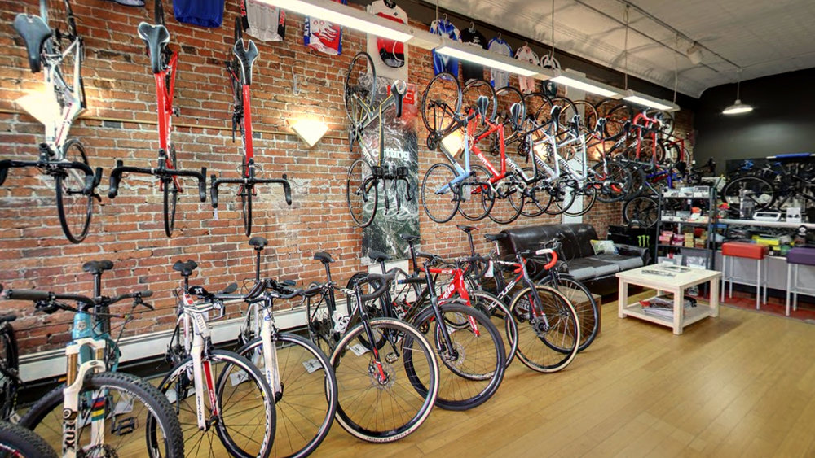

**The Mountain Spoke**

Site Plan

Carly Kjelstrom

crkjelstrom@gmail.com

**The Mountain Spoke Style Guide**

**Overview**

**Site Purpose**

The goal is to provide a fresh new website experience for their clients and potential clients that reflects their culture of bicycle enthusiasm with products, repair service, parts, and tour trips.

**Target Audience**

The Mountain Spoke is a fictitious, retail store and shop located in Bozeman, Montana specializing in bicycles, bicycle parts, bicycle repair, and tours. The owner-operated company caters to bicycle enthusiasts in that region. In addition, the company also sponsors and organizes tours in the area to serious bicyclists from around the world. Target ages are young adult to middle aged, or 21-40. The target gender is both male and female.

## Branding

### Website Logo

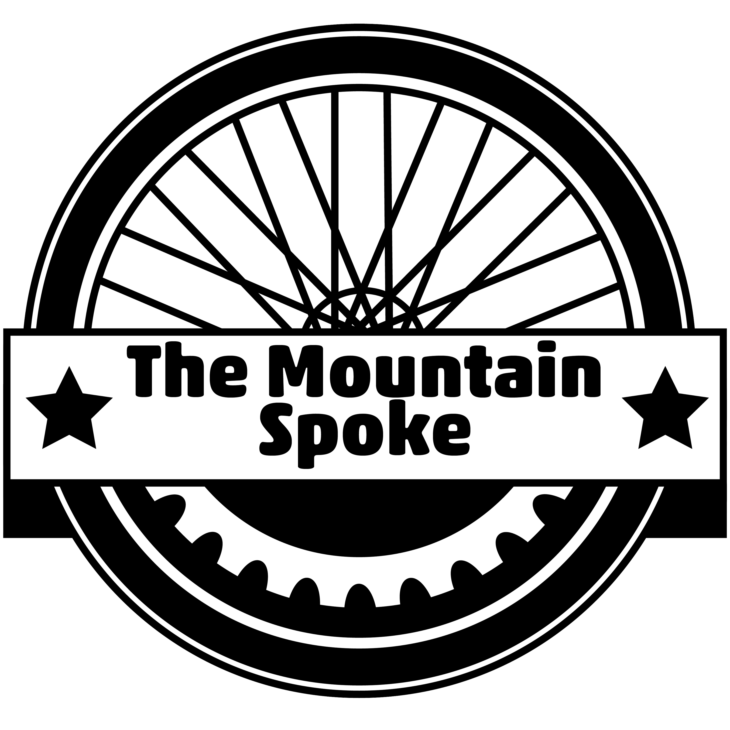

### Color Palette

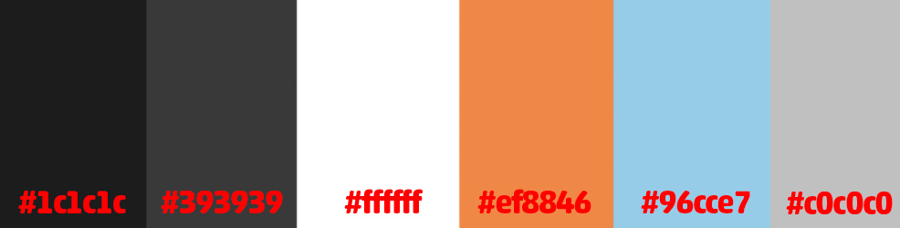

|  |  |  |  |  |  |
| --- | --- | --- | --- | --- | --- |
| Background | Header & Footer 1 | Header & Footer 2 | Buttons to site links | Words | Social Links |
| #c0c0c0 | #1c1c1c | #393939 | #ef8846 | #ffffff | #96cce7 |

## Typography

### Heading Font

#### ABCDEFGHIJKLMNOPQRSTUVWXYZ abcdefghijklmnopqrstuvwxyz 1234567890!@#$%^&*()_+

#### Sample Heading

I chose Akko Rounded Std Bold for the headings and subhedaings of the site. This is the same font I am using in my logo, so this provides repetition throughout the site.

### Body Copy Font

ABCDEFGHIJKLMNOPQRSTUVWXYZ  
abcdefghijklmnopqrstuvwxyz  
1234567890!@#$%^&*()_+

This paragraph will show how your paragraph text will look.

I chose Avenir Next Medium for the body font and most identifying information. This is a good contrast to the Akko because it is more crisp than Akko.

### Other Font

ABCDEFGHIJKLMNOPQRSTUVWXYZ  
abcdefghijklmnopqrstuvwxyz  
1234567890!@#$%^&*()_+

This paragraph will show how your paragraph text will look.

In case I need a third font for things like numbers or something else, I will use Egyptian Slate Regular. It is a serif font and works great for numbers.

## Navigation

### Main Navigation

The main color for the navigation bar will be the dark grey (#1c1c1c) with white words, and a bar of a lighter grey underneath the whole thing (#393939). The hover color is going to be the light blue (#96cce7). I’m hoping to have the current page stay in blue and be underlined.

|  |  |  |
| --- | --- | --- |
| Home | Adventures | Price Guide |
|  |  |  |

### Links

Link:normal : #000000

Link:hover : #116dc4

Link:current : #116dc4

## Layout

### Site Map

|  |  |  |  |  |
| --- | --- | --- | --- | --- |
|  |  | Home |  |  |
| Adventure Tours | Events | Shop (Sales) | Service | Contact |
|  |  |  |  |  |

### Wireframes

### 

### 